You have received this e-mail because the LBNL Retirees Association (EX-Ls) is inviting you to join us REMOTELY through ZOOM for our upcoming August quarterly speaker. You will continue to receive further information from EX-Ls regarding other lunches and events. If you would like to change your email address please send an email to: http://retirement.berkeley.edu/ex-ls with the words “Address Change” in the Subject line. Include your name and the old and new email addresses in the body of the email.
EX-Ls Retirement Association – News Online – Speaker Announcement
Join Us ….. EX-Ls August 19, 2021 ZOOM Speaker
Date: Thursday, August 19, 2021
Speaker: Gerald Przybylski REMOTE: Zoom Meeting
Time: 12:30 to 1:00 pm practice connecting, Speaker: 1:00 to 2:00 pm
Free Free Free Free
Register Here:
https://berkeley.zoom.us/meeting/register/tJwsdOioqDkoH9GpySAMMtSWQ3LqRRocg6W7
If you need help, please contact Kathy Bjornstad, EX-Ls Activities Coordinator kathy.bjornstad73@gmail.com

EX-Ls is proud to have SPEAKER: Gerald Przybylski, retired engineer from Lawrence Berkeley National Laboratory. From retirement to a family urban beekeeping business and expert.
TITLE: Keeping Honey Bees

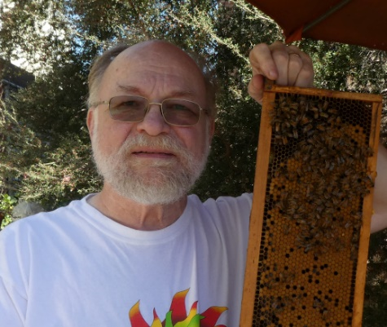
ABSTRACT: Beekeepers with a few hives in urban back yards, and in orchards with thousands of hives, practice a craft specialty rooted in aboriginal practices documented in cave paintings. Egyptians 4500 years ago first documented big-time beekeeping. Movable frame beekeeping revolutionized the art about 150 years ago. Modern equipment facilitated an explosion in basic research as well as development of efficient business models. Evolving parasites, and pathogens present new challenges. This program will touch on the high spots of a rich topic.

BIOGRAPHY: Gerald (Jerry) Przybylski’s father kept bees on a dairy farm in Wisconsin from the 1930's until 1960 when the family moved to the city. The work career spanned a stint in the Navy, two-way radio repair, an engineering degree from UC Berkeley, and finally an engineering job at Lawrence Berkeley lab for thirty years supporting the Physics division. The first Lab job was working for the PEP-4 Time Projection Chamber; the last big project was for the IceCube kilometer-scale particle astrophysics detector at the south pole. Upon retiring, with encouragement from biologist daughter, Jerry and spouse Laurel, after her career teaching in the Oakland Public Schools, took up urban beekeeping at their home in east Oakland starting 10 years ago. From two hives the first year, the yard has had from five to ten hives every year since, exclusively from colonies collected locally. For eight years, Jerry has been one of the volunteers answering the Alameda County Beekeeper Association's swam-hotline, VP of the club for several years, mentor coordinator for the club, and writer of the "Beekeepers' Corner" article in monthly newsletters.
We welcome new members to the LBNL Retirement Association the EX-Ls.

